Sales Automobile Using Salesforce CRM





**Team Members:** **Naan Mudhalvan ID:**

|  |  |  |
| --- | --- | --- |
| PAVITHRA J | | 20269872A5910C4AD444246BA7F80DFC |
| MONISHA M | | 94C7E0365A4106C994E492AED4EAF5EB |
| JOTHIKA P |  | 0062E8AABFC4B059646468DE7A3BA89A |
| KAVIYA K |  | BF947B376251C96BF474531847A6D73B |
|  |  |  |

**1.Project Overview:**

This project involves the development and customization of Salesforce CRM for managing the entire automobile sales process. The solution will enable streamlined sales operations, from lead management to the creation of invoices. The main features will include the creation of custom objects for automobile information, invoice management, and the automation of key processes such as opportunity and invoice handling.

The objective is to enhance the sales process by leveraging Salesforce's robust tools, including creating objects, fields, custom tabs, Apex triggers, Lightning Web Components (LWC), and more. This will help to manage customer accounts, automobile data, invoices, and related sales activities efficiently.

**2.Objective:**

The objectives for the Sales Automobile Using Salesforce CRM project are clearly defined to ensure measurable success and alignment with both business and technical goals. These objectives guide the development process and ensure the solution will meet the needs of the business, sales teams, and customers.

 The business goals of the Sales Automobile Using Salesforce CRM project are to streamline and optimize the entire sales process, from lead generation to invoice creation, by leveraging Salesforce's powerful CRM capabilities. The project aims to increase sales efficiency by automating key processes, enhance customer engagement through a 360-degree view of customer data, and improve data accuracy for better decision-making. Additionally, the solution seeks to optimize inventory management by providing real-time visibility into stock levels and sales trends, accelerate invoice processing for faster revenue realization, and drive business growth by enabling better tracking, reporting, and forecasting of sales performance. The specific outcomes of the Sales Automobile Using Salesforce CRM project include the creation of custom objects and fields for managing automobile inventory, sales opportunities, and invoices, which will be fully integrated into the Salesforce platform. The project will deliver automation through Apex triggers and workflows to streamline sales processes, from generating invoices to tracking opportunity quantities. Custom tabs and page layouts will be developed to improve user experience, while the Salesforce Lightning App and Lightning Web Components (LWC) will enhance accessibility and interactivity across devices. Additionally, comprehensive reports and dashboards will be implemented to provide realtime insights into sales performance, inventory levels, and customer interactions. This integration and automation will result in faster, more accurate data entry, improved operational efficiency, and enhanced decision-making capabilities for sales teams and management.

**3. Salesforce Key Features and Concepts Utilized:**

* **Custom Objects & Fields:**

Custom Objects like Automobile Information and Invoice store specific data related to the sales process, allowing you to track cars, pricing, and invoices in Salesforce.

* **Page Layouts & Lightning Apps**:

Custom Page Layouts for Opportunities and Invoices ensure relevant information is easily accessible, while a Lightning App consolidates the interface for users to manage their workflow efficiently.

* **Apex Triggers & Classes:**

Apex Triggers automate processes such as updating the automobile quantity in an Opportunity and creating an invoice when an Opportunity is closed, reducing manual tasks.

* **Lightning Web Components (LWC)**:

A custom LWC component displays related Invoice data on Opportunity pages, enhancing the user interface and providing real-time access to invoice details.

* **Reports & Dashboards**:

Reports and Dashboards provide visual insights into sales performance, inventory levels, and invoice statuses, helping track business health and sales trends.

* **Salesforce Lightning Experience**:

The **Lightning Experience** improves user productivity with an intuitive and responsive interface, allowing users to efficiently navigate and manage automobile sales data ➢ **Apex Schedulers**:

Apex Schedulers automate recurring tasks, such as sending invoice reminders or syncing data, ensuring timely actions without manual intervention.

**4. Detailed Steps to Solution Design for Automobile Sales Management in Salesforce:**

* **Automobile Information Object:**

This object stores data related to the automobiles sold, such as make, model, year, price, and VIN.

* **Invoice Object**:

This object holds details about invoices related to Opportunities.

* **Automobile Object**:

This object may track additional attributes related to automobiles or individual transactions (e.g., specific inventory details).

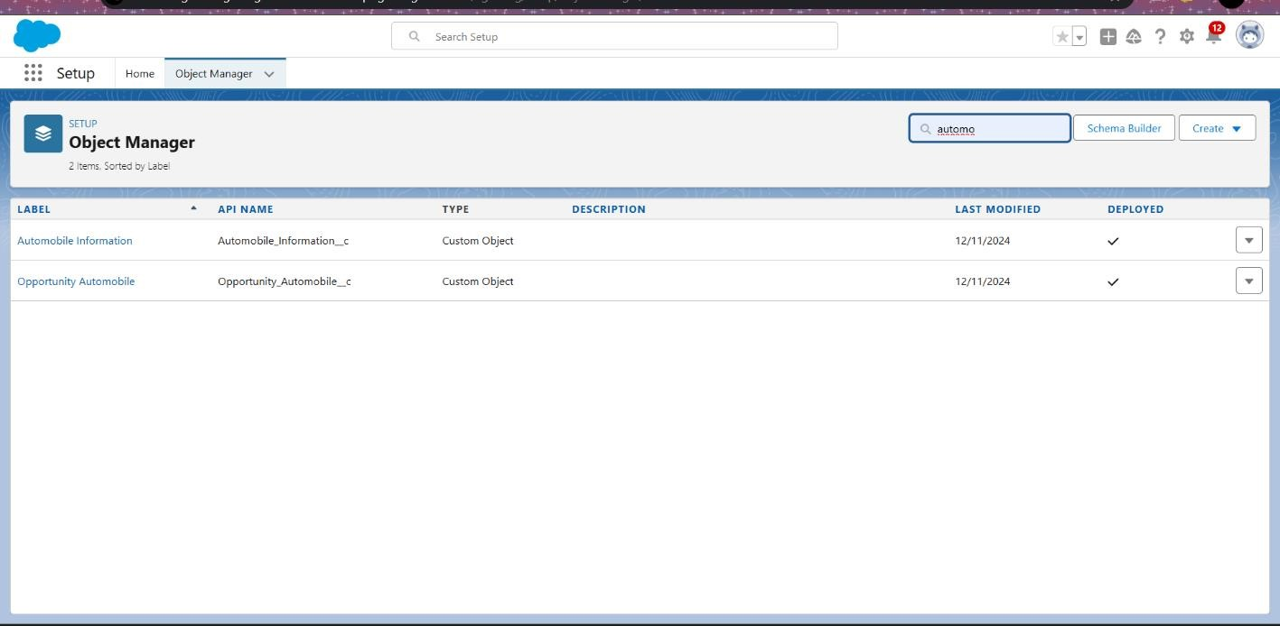

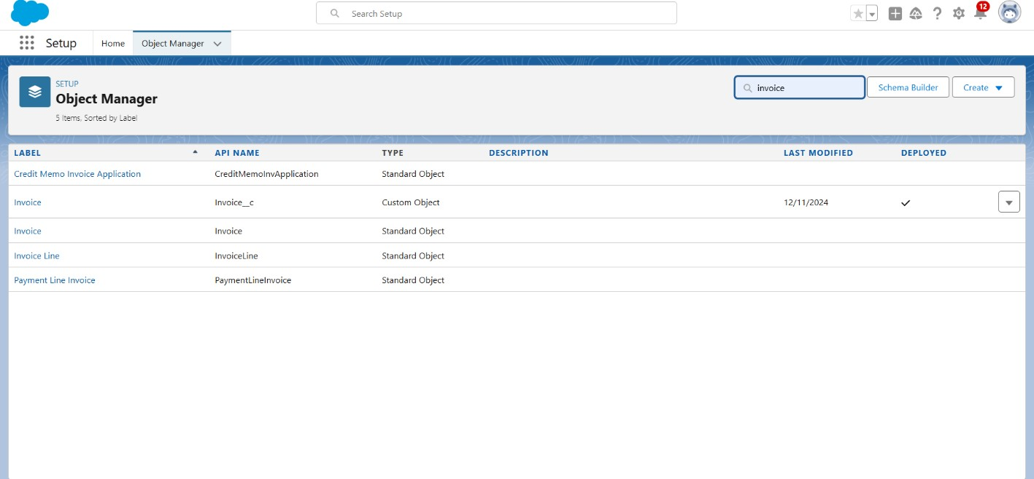

* **Creating a Custom Tab:**

Custom object tabs are the user interface for custom applications that you build in salesforce.com. They look and behave like standard salesforce.com tabs such as accounts, contacts, and opportunities.

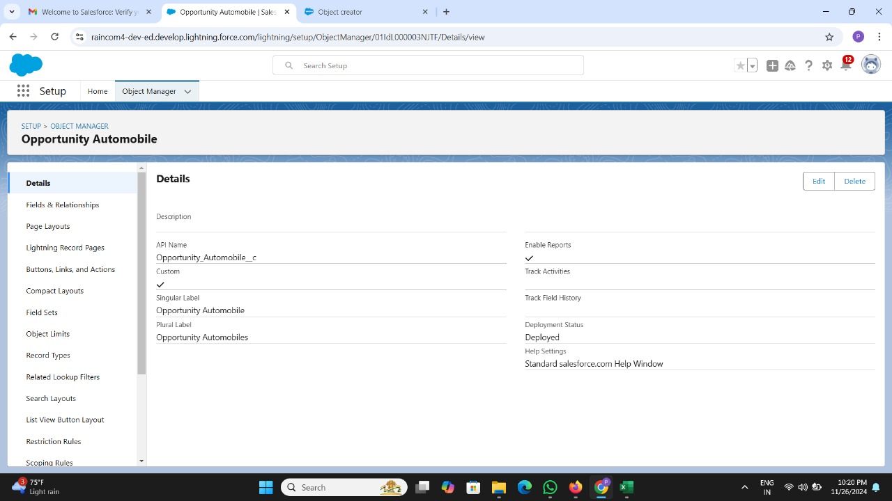

* **Lightning App**

•Create a Custom Lightning App that integrates the following components: oOpportunity Records oAutomobile Information records oInvoices related to Opportunities The app should include: oNavigation to all relevant objects (Opportunities, Automobiles, Invoices).

oA dashboard to visualize Total Sales, Invoices due, Opportunity stage.

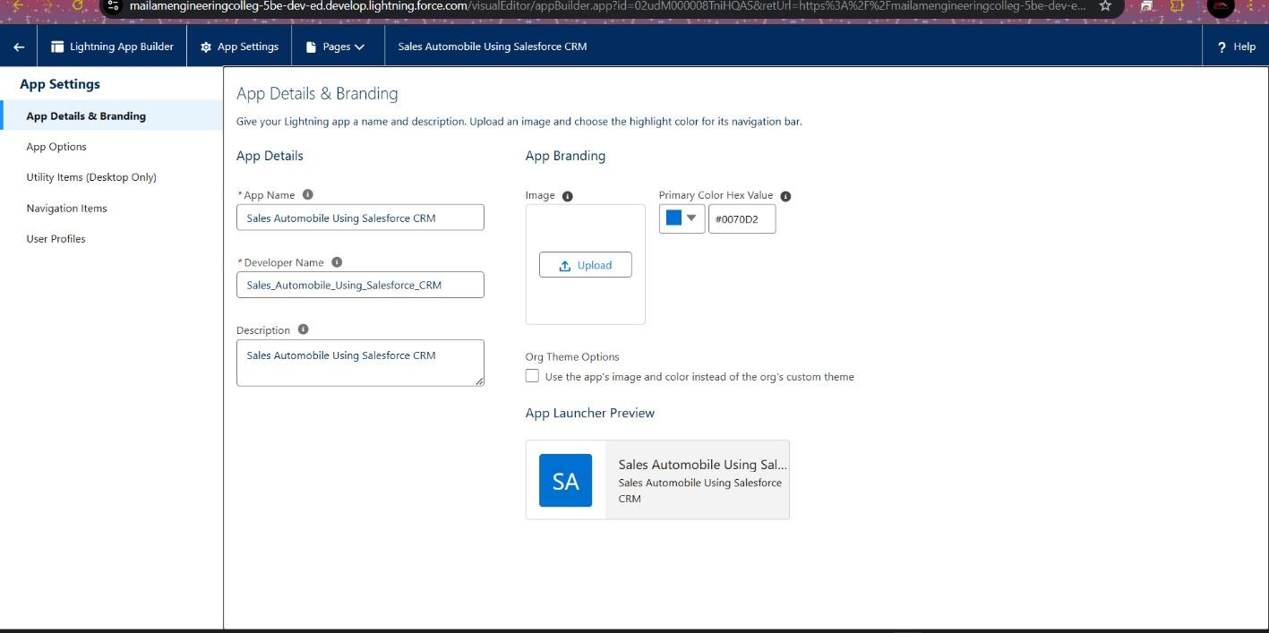

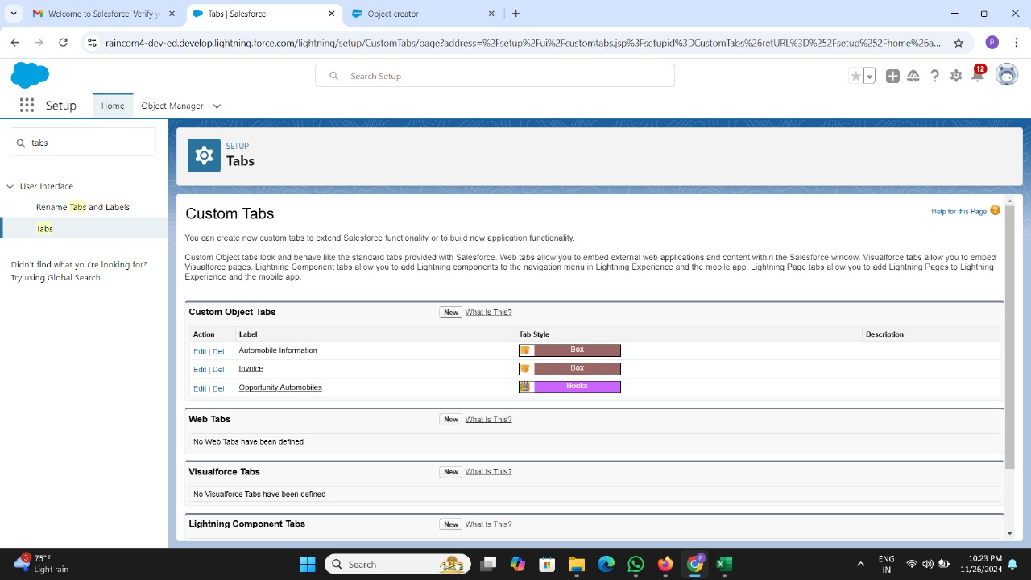

* **Creating Fields and Relationships:**

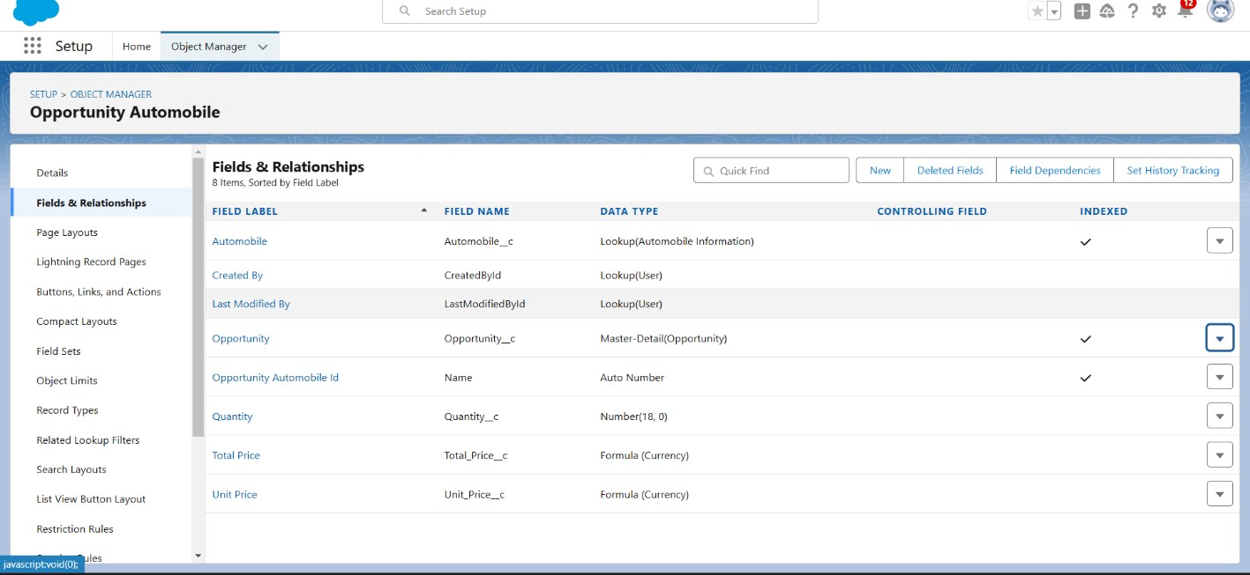

* **Page Layouts:**

Page Layout in Salesforce allows us to customize the design and organize detail and edit pages of records in Salesforce. Page layouts can be used to control the appearance of fields, related lists, and custom links on standard and custom objects' detail and edit pages.

**Edit the Page layout for Automobiles Information**

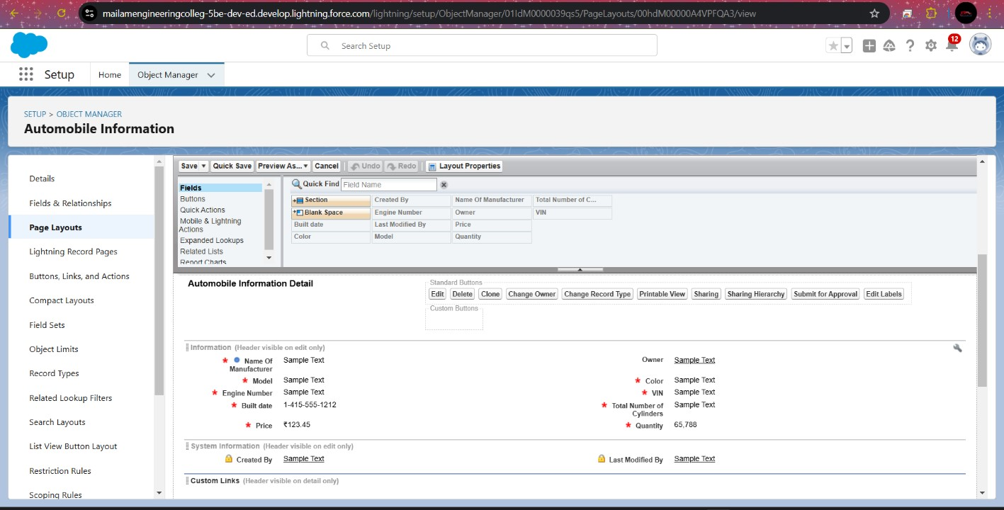

* **Apex Triggers:**

An Apex trigger is a set of instructions that execute when certain events occur on a Salesforce object (like when a record is created, updated, deleted, or restored).

**Creating OpportunityHandlerClass**

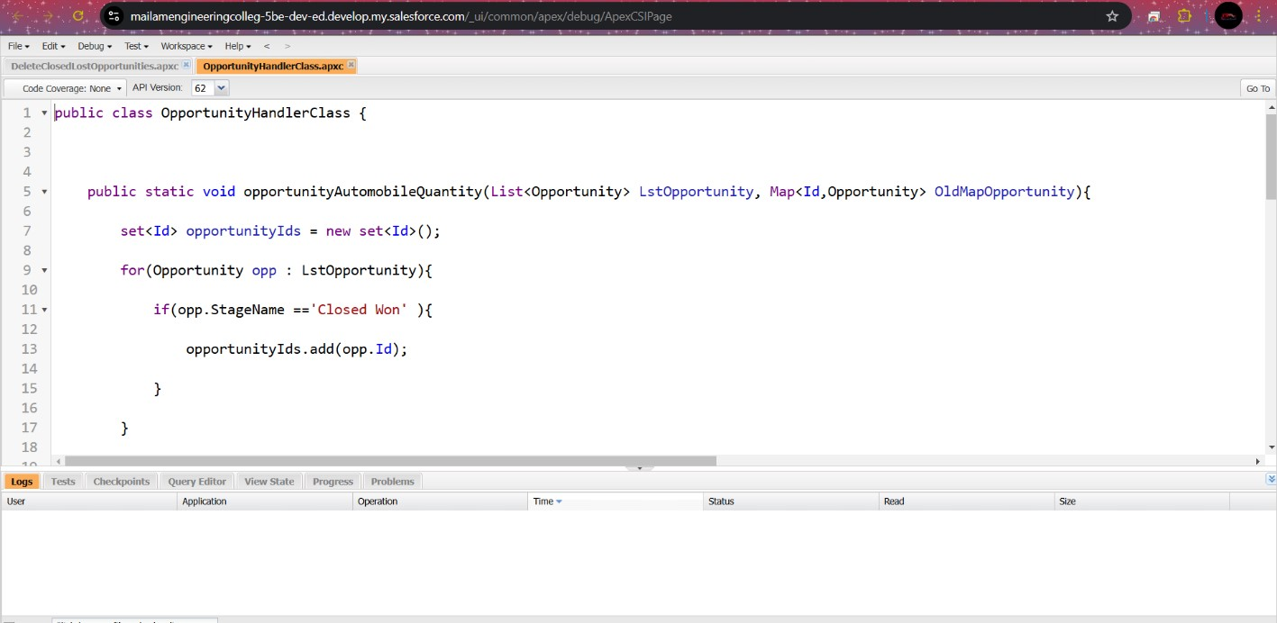

**Creating OpportunityAutomobileHandlerClass**

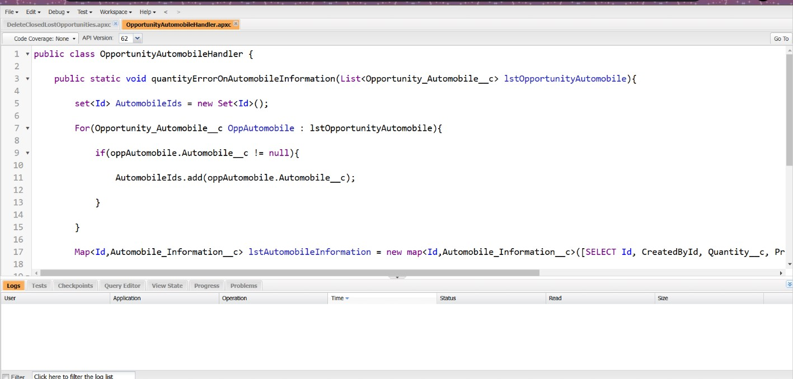

**Creating OpportunityAutoMobileTrigger**

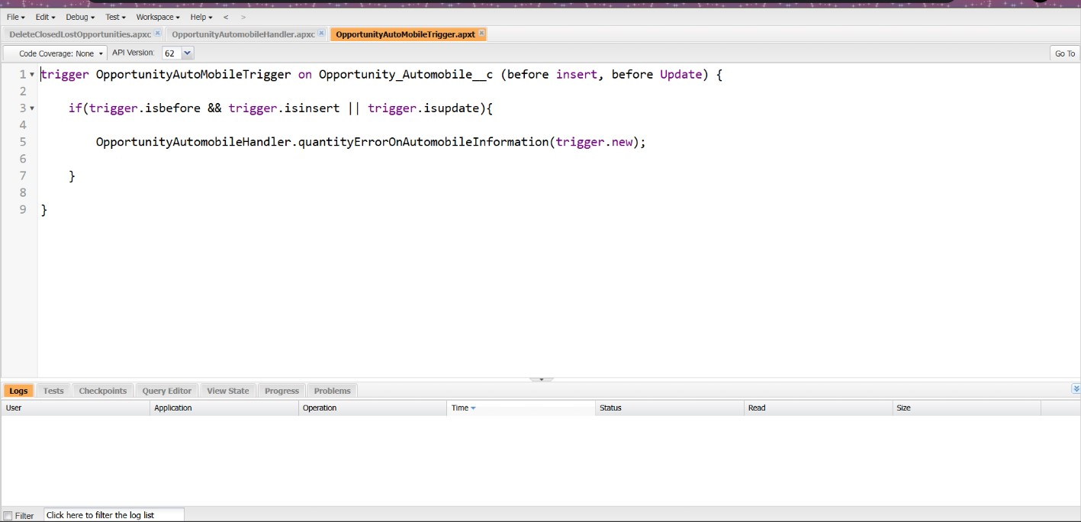

**Creating InvoiceCreation class**

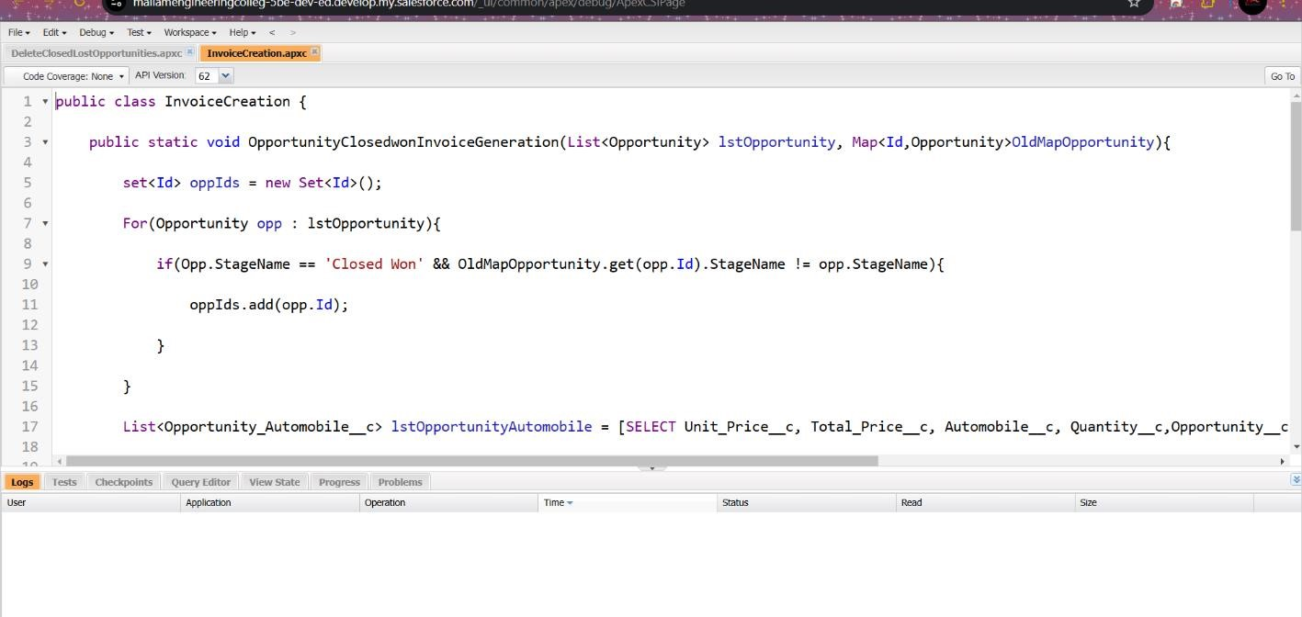

**Creating ContactRoleCheck class**

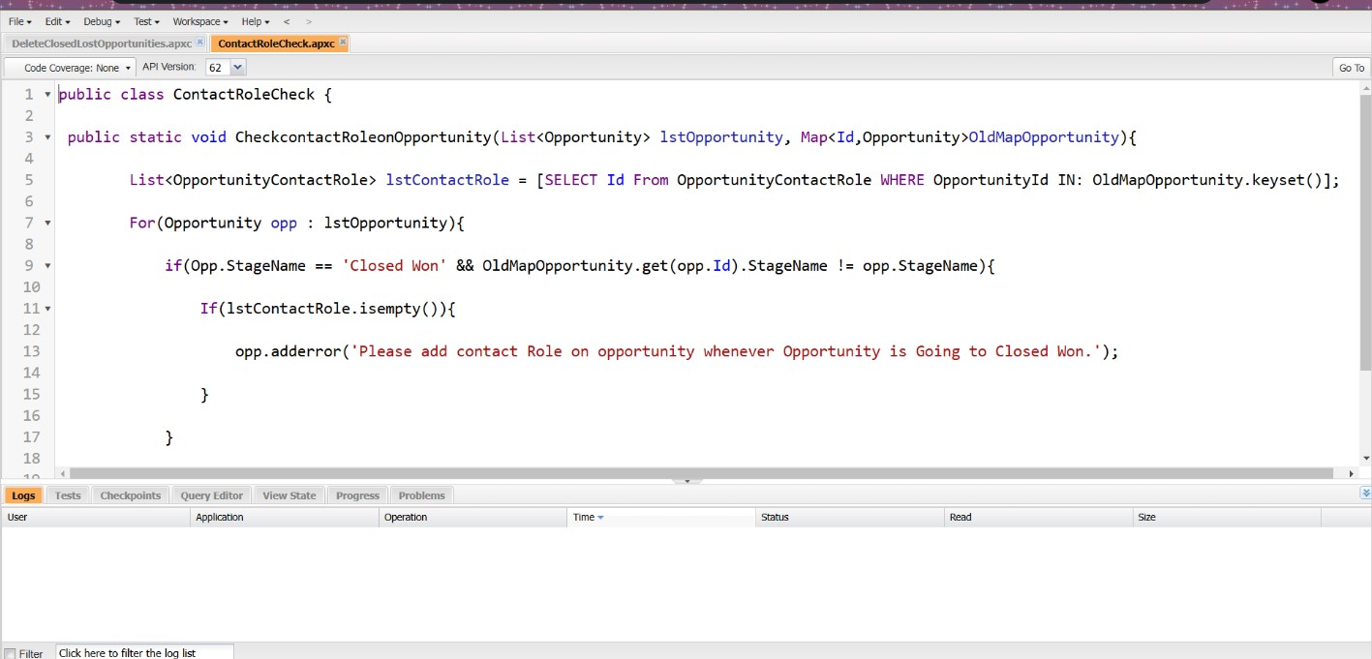

**Creating OpportunityTrigger**

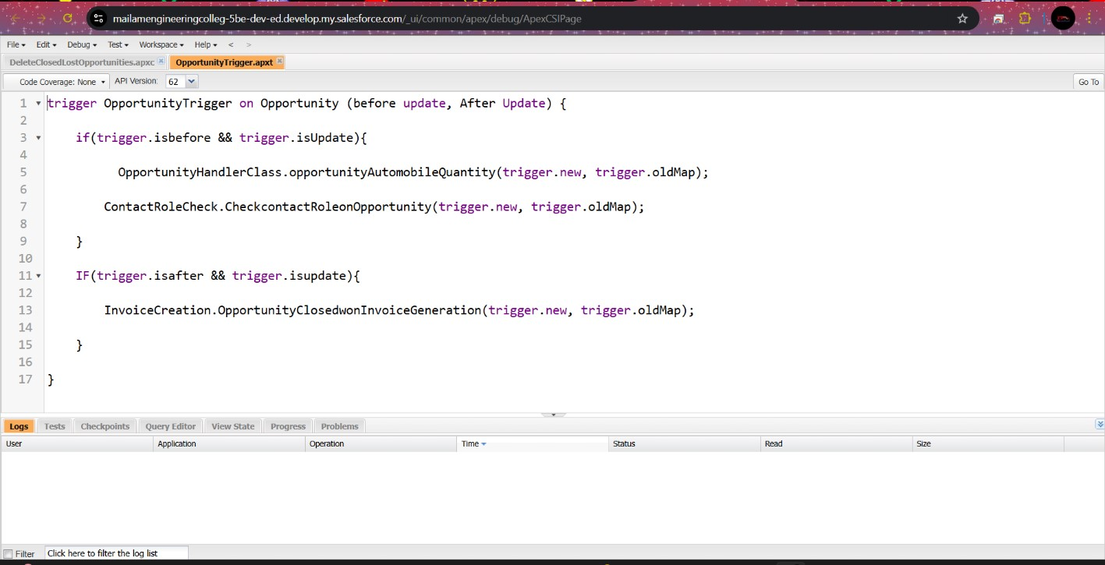

* **LWC Component:**

Lightning Web Components (LWC) are a modern framework for building user interfaces in Salesforce. Unlike Aura Components (Salesforce's previous framework), LWC is based on modern web standards, including web components, HTML, CSS, and JavaScript. It offers faster performance, better developer productivity, and is more aligned with web development best practices.

**Create apexclass to get invoice**

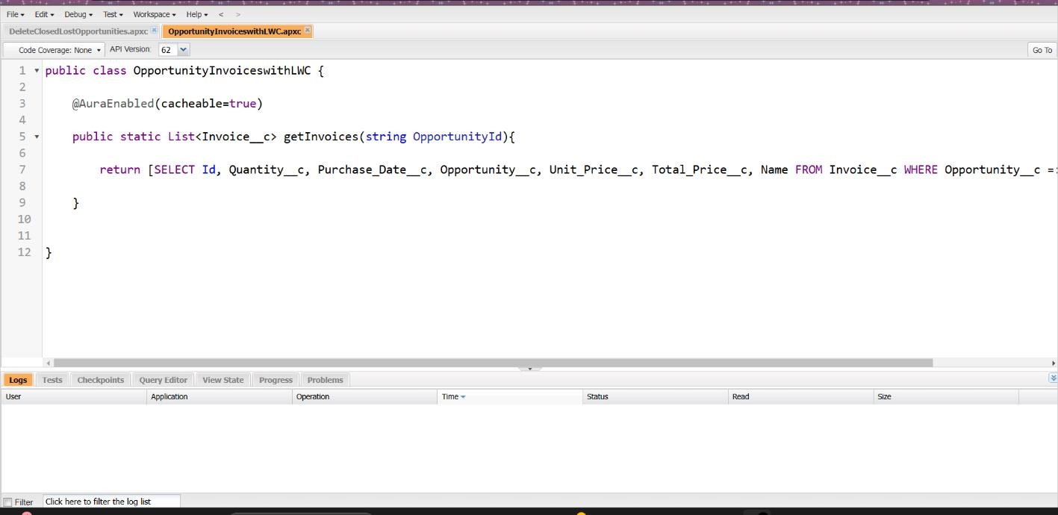

**Create Lightning Web Component** The lwc component name is InvoiceOpportunity.

# XML File

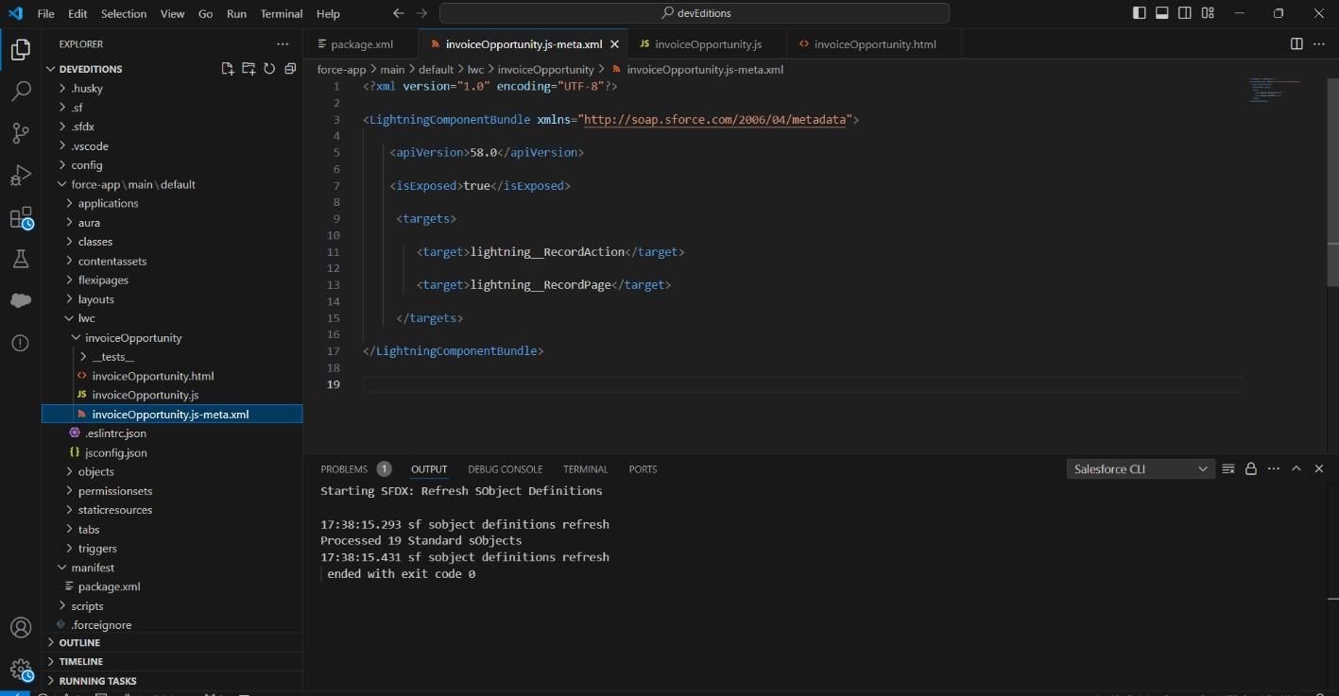

# JS File

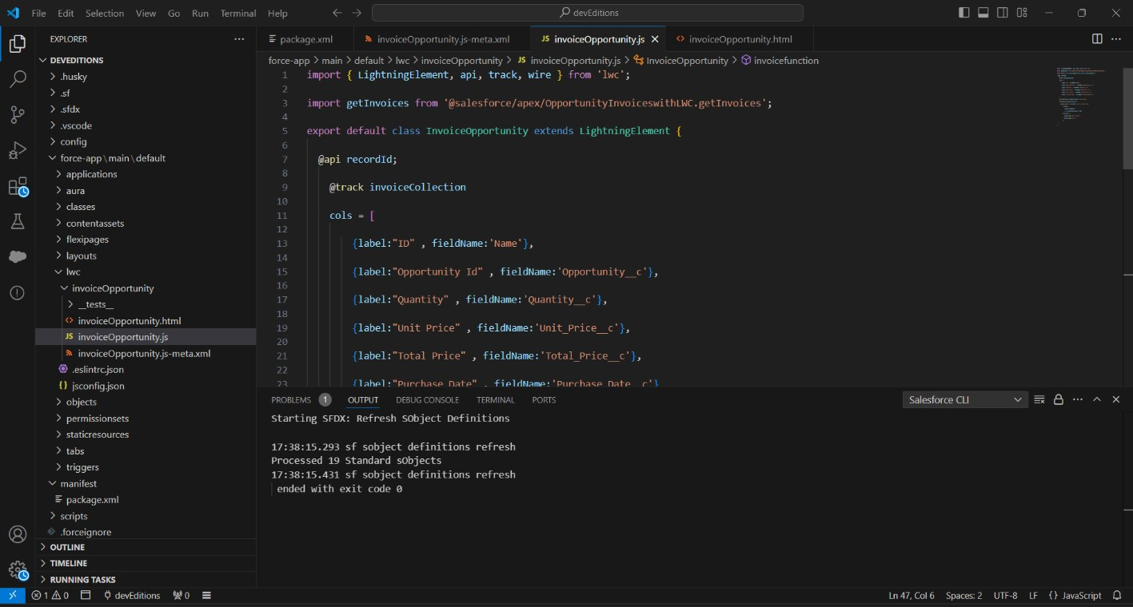

**HTML File**

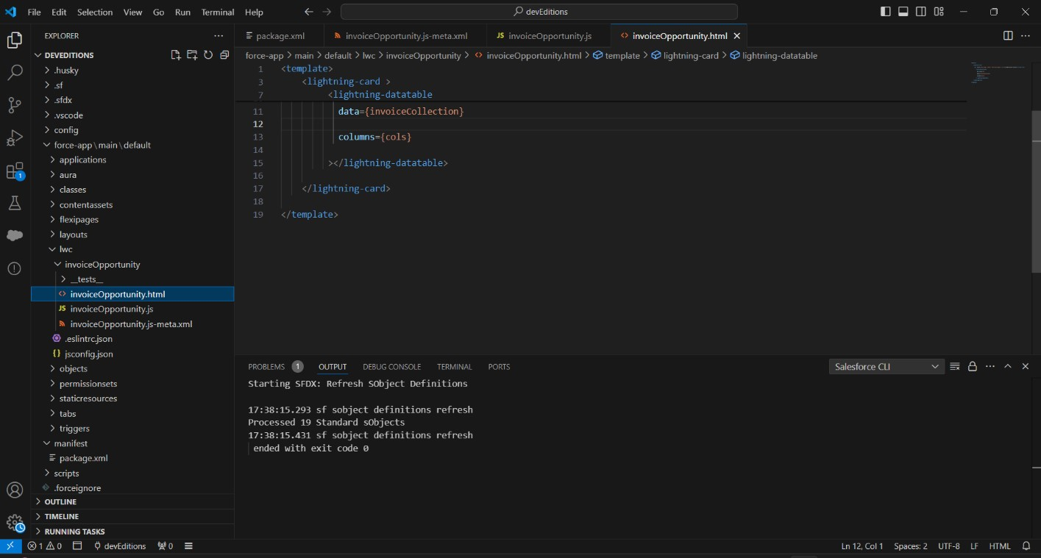

**Create Button to add an opportunity**

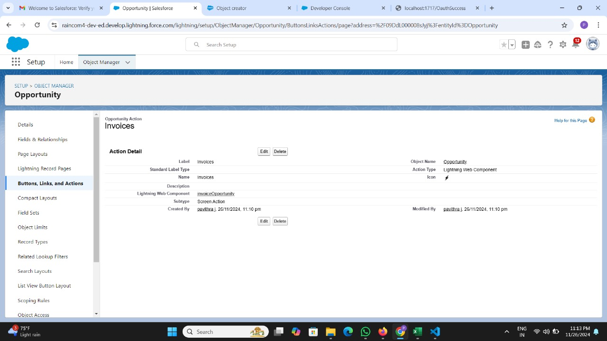

# Add Invoice opportunity into opportunity record page

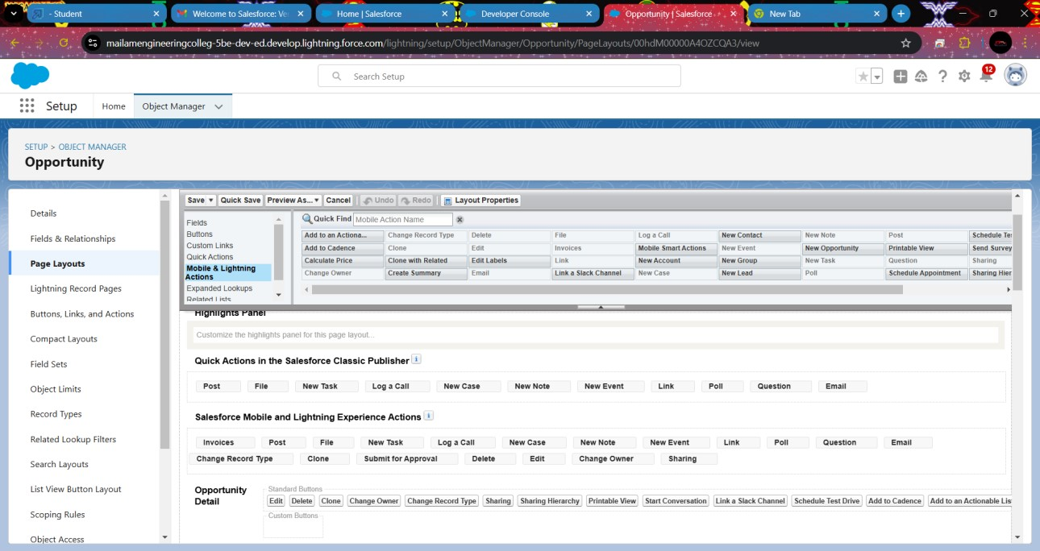

* **Apex Schedulers:**

**Delete opportunity schedule class**

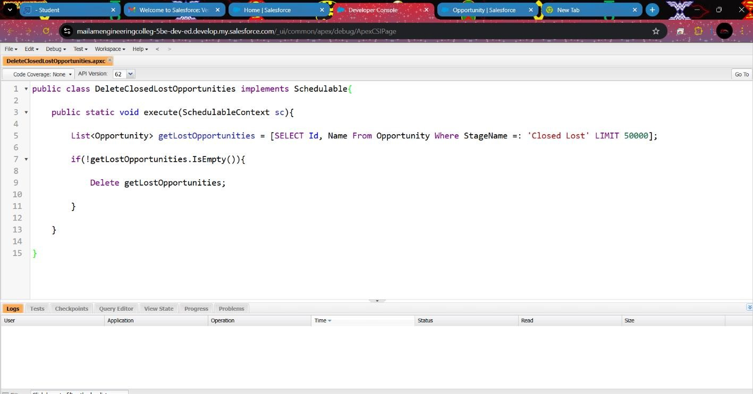

* **Reports:**

Reports give you access to your Salesforce data. You can examine your Salesforce data in almost infinite combinations, display it in easy-to-understand formats, and share the resulting insights with others. Before building, reading, and sharing reports, review these reporting basics.

Here we create three reports namely Opportunity with automobile data, opportunity closed won report,and Automobile Information report.

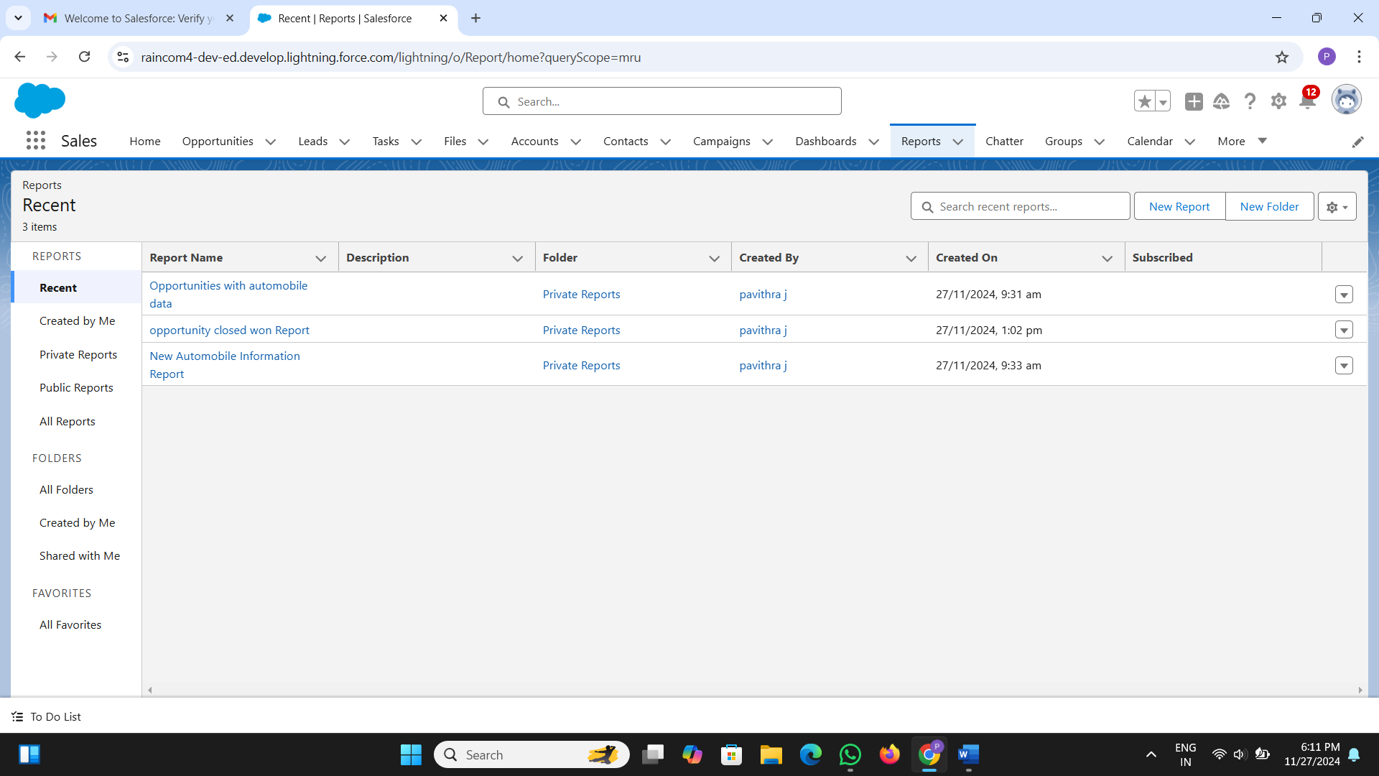

* **Dashboard:**

Dashboards help you visually understand changing business conditions so you can make decisions based on the real-time data you’ve gathered with reports. Use dashboards to help users identify trends, sort out quantities, and measure the impact of their activities.

The Created Dashboard:

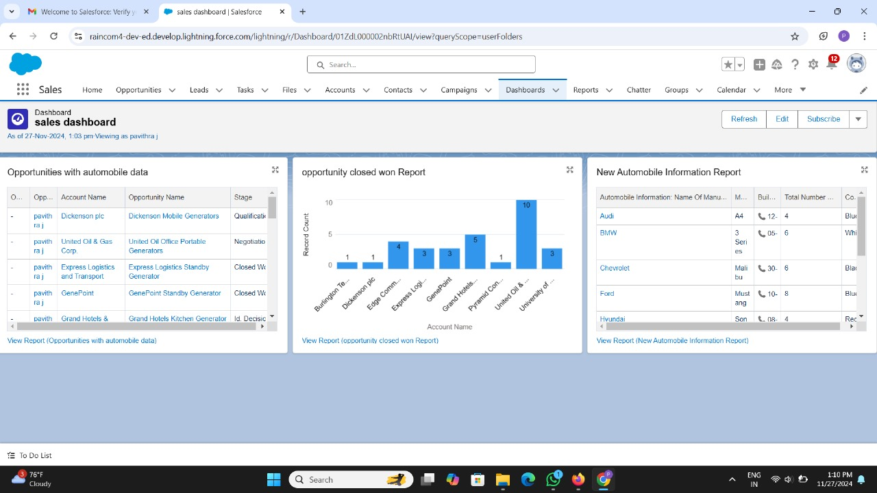

1. **Testing and Validation for the Automobile Sales CRM Project:**

In the Automobile Sales CRM project, testing and validation play a crucial role in ensuring the reliability, accuracy, and overall functionality of the application. The project involves multiple components such as Apex classes, Apex triggers, Lightning Web Components (LWC), and custom objects. For Apex classes and triggers, unit tests are designed to verify business logic, such as calculating automobile prices, updating opportunity quantities, and handling complex workflows. These unit tests simulate real-world scenarios by inserting mock data and validating outcomes with assertions. Additionally, tests cover edge cases, such as handling invalid or missing inputs, ensuring that the system behaves as expected under all conditions, and confirming that bulk processing does not exceed Salesforce governor limits. Apex test classes ensure that the code is fully covered (with at least 75% test coverage) and compliant with Salesforce’s deployment requirements.

For the user interface (UI), testing focuses on Lightning Web Components (LWC) to ensure that the system is intuitive, responsive, and user-friendly. The UI testing validates the correct functionality of components such as automobile search, invoice generation, and opportunity management. Tests are implemented to simulate user interactions, such as filtering automobiles by make, adding items to opportunities, and updating quantities. Using Jest for testing LWC, developers verify that components respond correctly to user input, trigger appropriate events, and dynamically update the interface based on realtime data. These tests ensure that the final product offers a seamless user experience, with minimal bugs or UI inconsistencies, and that all components interact smoothly with Salesforce’s backend systems.

1. **Key Scenarios Addressed by Salesforce in the Implementation Project:**

**1.Managing Automobile Inventory**

**Scenario:** The business needs to manage a dynamic inventory of automobiles with details such as make, model, price, stock availability, and other relevant attributes. The sales team needs a centralized system to view and update automobile information in real time.

**Salesforce Solution:**

* Custom Object for Automobile Inventory: A custom object is created to store automobile details (e.g., model, price, stock quantity).
* Lightning Web Component (LWC) is built to enable the sales team to view and search for automobiles in real time.
* The system can auto-update stock quantities based on sales or returns through Apex triggers.

**2.Customer Relationship Management (CRM)**

**Scenario**: The business needs to track detailed customer information, including contact details, previous interactions, and automobile purchases. The system should also allow for effective follow-ups and communication with leads, prospects, and customers.

**Salesforce Solution:**

* Contact and Account Management: Salesforce’s Contact and Account objects are customized to track customer information and interactions related to automobile purchases.
* Lead Management: Leads are captured through forms or imports and converted into Opportunities when ready for further engagement.
* Task and Event Tracking: Salesforce’s Task and Event functionalities are used to create reminders, track follow-up calls, and schedule meetings with customers.

**7. Conclusion:**

The Automobile Sales CRM project has successfully implemented a comprehensive solution that streamlines key business processes, enhances sales operations, and improves customer relationship management. By leveraging Salesforce's powerful features, including custom objects, Apex triggers, Lightning Web Components (LWC), and automation tools like Process Builder and Flows, the project has effectively addressed critical use cases such as managing automobile inventory, tracking sales opportunities, generating invoices, and automating workflows. The system enables real-time data updates, detailed reporting and analytics, and seamless integration of sales and customer data, ultimately driving increased sales efficiency and better customer experiences. Through this implementation, the business now has a scalable, flexible CRM solution that supports both operational needs and strategic growth.